Exercise 1: Downloading and installing Node.js and npm

Objectives and Outcomes
Node.js is a server-side JavaScript code execution environment, while npm (Node Package Manager) is a package management tool for Node.js. To develop JavaScript applications or run Node.js-related tools, you need to download and install both Node.js and npm on your computer. At the end of this exercise, you would be able to:
Installing Node.js and npm

Installing Node
Downloading and installing Node.js and npm includes the following steps:
- Download the Node.js installation package from the official website.
- Run the installation package and follow the on-screen instructions to complete the installation.
- Verify the installation was successful by opening a terminal and running the Node.js and npm version check commands.

Guidelines
Step 1: Visit the official Node.js website (https://nodejs.org).
Step 2: On the website, you will see two recommended Node.js versions: LTS (Long-Term Support) and Current. For general purposes, choose the LTS version for stability and long-term support.
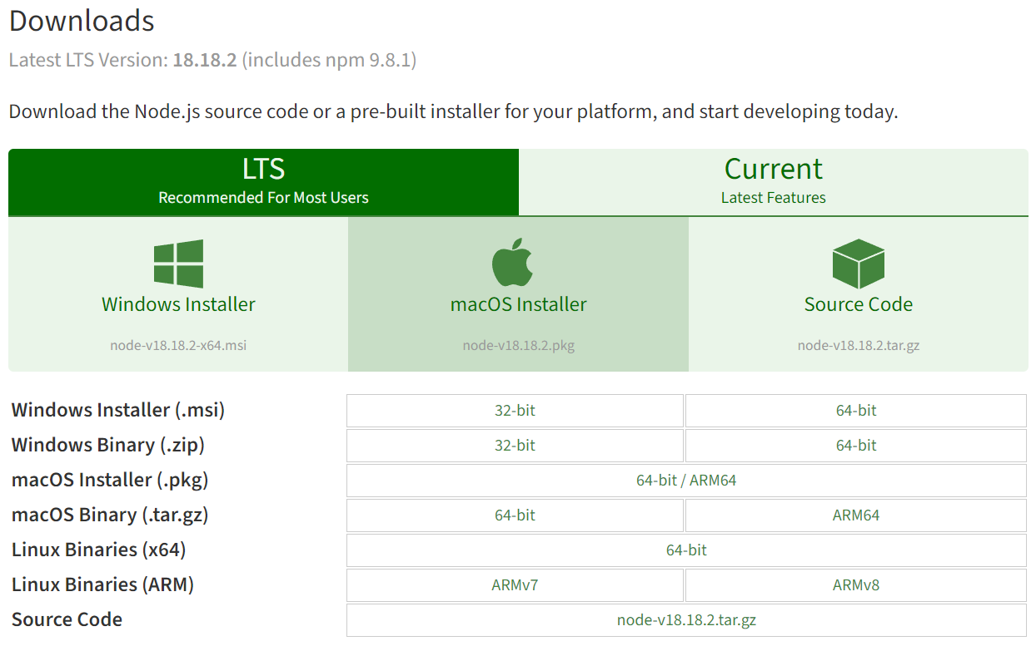
Step 3: Click on the Node.js LTS version to download the installation package.
Step 4: Once the installation file has been downloaded, run the installation file to start the installation process.
For Windows: Double-click the installation file (.msi) and follow the onscreen instructions. Select the appropriate installation path and options.
For macOS: Open the installation file (.pkg) and follow the onscreen instructions. Select the appropriate installation path and options.
For Linux: Open terminal, navigate to the directory containing the installation files and run the following command to install:
sudo dpkg -i installation_filename.deb
(Replace "installation_filename.deb" with the actual name of the installation file you downloaded)
Step 5: Once the installation is complete, check the installed Node.js version by opening a terminal and running the following command:
node -v
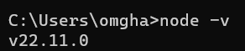
If the Node.js version is displayed, the installation was successful.
Step 6: Next, to test the npm installation, run the following command in terminal:
npm -v
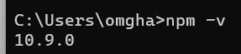
If the npm version shows up, the installation was successful.

Conclusions
Downloading and installing Node.js and npm is an important process for developing and running Node.js-related JavaScript applications. By following the above instructions, you can successfully set up a Node.js development environment on your computer.

